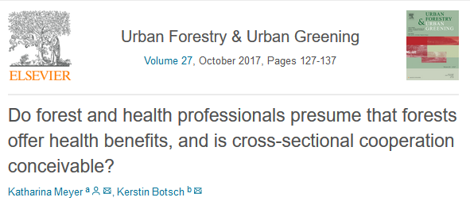
a katharina.meyer@forst.uni-goettingen.de, b Kerstin.Botsch@nlp.bwl.de

Abstract
In high-income countries depression and cardiovascular diseases were predicted to be the two leading causes of DALYs in the year 2030. Private-life stress fosters both kinds of diseases. Scientific findings already show that forest exposure has stress-reducing effects. Particularly in Japan, people have practiced forest bathing to improve their health. The German population also has a strong connection to its forests, and forest law allows forest access, regardless of ownership structure. Hence, the question arises of whether forest exposure could be used in Germany as a kind of stress-coping strategy. To a certain degree, the success of such a strategy in Germany would require the participation of the stakeholders that are active in both the health and the forestry sectors. Therefore, it seems necessary to gain insight into German forest and health professionals' understanding and attitude concerning forest-related health benefits. For this reason, in this pilot study, guideline interviews with professionals of both sectors and with professionals standing in between these professions were conducted, recorded and transcribed. On the one hand, each professional’s presumptions regarding the health-fostering effects of forests were investigated, derived from their subjective certainty that forest exposure has health-fostering effects. In addition, a thought experiment was used to estimate the level of willingness to cooperate with each other in order to motivate people to be physically active in forests. For analysis, Mayring’s qualitative content analysis and a frequency analysis (MaxQDA) were applied. Findings show that most of the interviewed professionals presume forests to have health-fostering effects. Furthermore, something derived from the statements within the context of the thought experiment was that most professionals seem to be willing to cooperate with the other sector. Hence, it might be conceivable that forest exposure may be part of a German stress-coping strategy.

Keywords
Content analysis, Forest health benefits, Forest exposure, Guideline interviews, Stress coping strategy

